Crossword Puzzle | Name:________________________
Waves and Sound
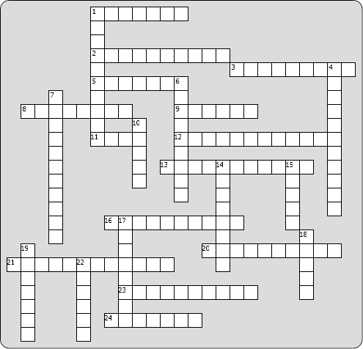
Across: | Down:
1 - this is at the bottom of the ear canal  2 - water waves on the ocean are these kind of waves  3 - measured in units called "Hertz"  5 - snail-shell-shaped part of the inner ear  8 - waves on a violin string, that doesn't look like it's traveling  9 - the time needed for one wiggle of a wave  11 - end of a violin string, that is not moving  12 - when waves overlap, you can get constructive and destructive ______  13 - the lowest frequency out of the many frequencies produced by a musical instrument  16 - the distance from one crest to the next  20 - light waves are these kinds of waves  21 - sound waves are these kinds of waves  23 - what the stirrup presses against (two words)  24 - the unit used for measuring loudness | 1 - this tube allows air pressure in your middle ear to equalize with the outside air pressure  4 - the high-pressure part of a sound wave  6 - the height of a wave  7 - the low-pressure part of a sound wave  10 - warbling noise heard when two sounds are nearly, but not exactly, the same frequency  14 - this nerve transmits signals to your brain  15 - one of the three bones in the middle ear  17 - the middle of a violin string, that is wiggling a lot  18 - the high point of a wave  19 - the change in pitch when a wave source comes towards you (or moves away) = ____ Effect  22 - the low point of a wave

